10 Common Resume Errors You Must Avoid
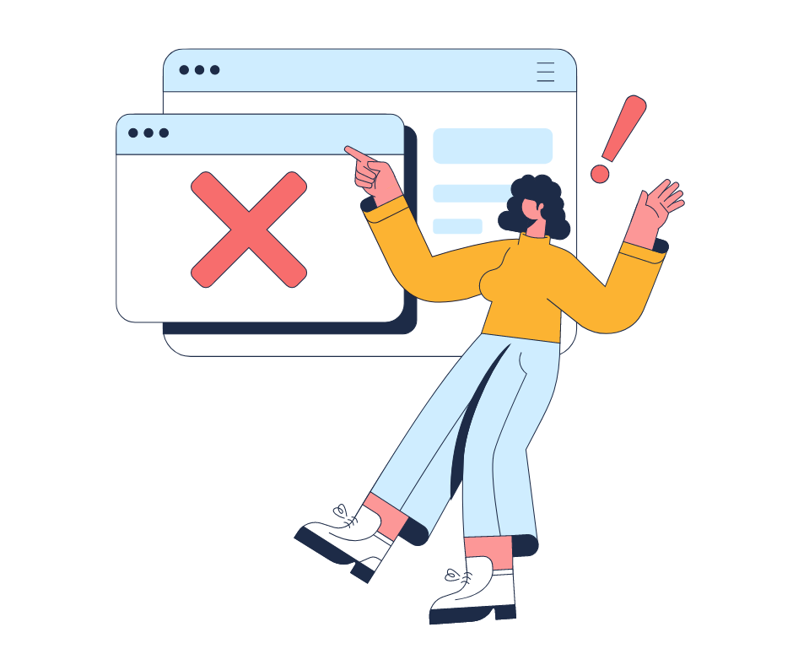

Are you struggling to get that dream job? You may have all the necessary skills & qualifications but still lack something. Maybe you are making some common resume mistakes.
Crafting a compelling resume might be easier if you know which resume errors to avoid. This blog will take you through the top resume mistakes & how you can avoid those to build a smart & effective resume.

Grammatical or Linguistic Mistakes
One of the common resume writing errors is grammatical & linguistic mistakes. Grammatical mistakes in your resume might make it less compelling & leave a negative impression on your hiring manager. You may be even viewed as unprofessional or careless.
Proofreading your resume for grammatical errors before sending it out should be practiced regularly. Asking someone to review it may help you to find those mistakes that you might have overlooked.

Inaccurate or Unnecessary Information
Inaccurate information can cost you your next job. Your resume might be perfect or top-notch, but you may not get that job just because you added a wrong phone number or email address.
Leave out irrelevant or unnecessary information like your family details, religious beliefs or your political views. Nobody would like to see that. Beware of using unprofessional email addresses as it may make you look immature.

Poor Formatting
Inconsistent font sizes or leaving too much white spaces can reflect badly on your personal brand. A recruiter spends just a few seconds on each resume. Therefore, it is very important to catch your recruiter’s attention in those few seconds.
Your resume must be easily readable, scannable & should display the information recruiter’s need readily. Use bulleted points & stick to a particular color or font throughout your resume.

Not tailoring your resume
Sometimes you may neglect to tailor your resume as per the job you are applying for. People tend to send out the same resumes for different job roles. They fail to recognize that many hiring managers use the Applicant Tracking System (ATS) that scans the resume for keywords related to the job.
Make it a habit to use keywords relevant to the industry you work for. Look for such keywords in the job description. Add specific skills & responsibilities to your resume that match the criteria for the job.

Outdated Resume
Are you still stuck in the same resume that you used to get your first job? Maybe you took many jobs after that but have still not updated it to your resume.
Your jobs are your assets that you must proudly mention in your resume. These jobs can reflect your experience & help you land that job.

Including a Photo
If your recruiter does not ask for a photo, its best not to include it in your resume. As mentioned earlier, many recruiters use the ATS. These systems are not able to scan a photo which may lead to rejection of your resume.
In many cases, it is safer & more effective to focus on presenting your qualifications & experience in a clear & professional manner without including a photo.

Not enumerating your accomplishments
Quantifying your achievements in your resume is highly effective because it provides concrete evidence of your impact & contributions in previous roles. It demonstrates tangible results for the jobs you have done in your past
It highlights your value & sets you apart by mentioning not just what you did but what impact you created by how you did it. This increases credibility thus. Making your claims more believable.

Lengthy Resume
Studies show that it only takes a recruiter 7.4 seconds to scan through your resume. You need to really grab the recruiter's attention at this time.
If your resume is lengthy, say 7-8 pages long, the recruiter might reject it even without reading it. Therefore, craft a resume which is just 1-2 pages long highlighting all your skills & accomplishments.

Lying on your resume
Lying on your resume is never a good idea no matter how desperate you are for the job. You may think that it is easier to lie & get the job than losing the job. But the reality is that once you get caught in this unethical practice, there is no way out.
You will lose the recruiter’s trust, perhaps even your job. Therefore, aim to fill your resume with relevant information rather than lies.

Not including a cover letter
Submitting a cover letter is a good practice even when you are not asked to do so. This reflects your willingness & enthusiasm for the job you are applying for.
Cover letters can describe your personality & values in the way you want it to be portrayed to your hiring manager. This will make you stand out from the rest of the candidates that did not provide a cover letter.

Conclusion
Attention to detail is a skill you must possess while creating the perfect resume. Avoiding the above mistakes in resume writing may allow you to be successful in your career.
PaintMinds is the most effective resume builder online. Do you want to avail yourself of the chance to build a professional resume? Visit the PaintMinds website & get guidance from experts to build an ATS-compliant resume.

Keywords: Common resume mistakes | Resume errors to avoid | Resume writing errors | Top resume mistakes | Mistakes in resume writing | Common resume errors

Title tag: Avoid these common Resume Errors & build a Professional Resume

Meta Description: Resume Writing is a tedious job when you do not know where to start from. Read this blog to know about the common resume mistakes people make & how you can avoid those & stand apart from the crowd.

Meta tag: How to avoid the common resume mistakes | PaintMinds

